Evaluation of PIP5K1A association with DFS in classical-like and basal-like subtypes of Pancreatic Adenocarcinoma in TCGA-PAAD
The analysis was carried out locally on R using the survival and survminer packages on TCGA_PAAD dataset. Out of the 182 samples, 150 contained data on the classification based on classical-like and basal-like subtypes of cancer.
Basal-like subtype | 65 samples
Classical-like subtypes | 85 samples

The PIP5K1A expression was divided into low and high expression categories using the median expression level as the cutoff value. DFS data was imported into R from cBioPortal suing the clinical data file since the original TCGA pan dataset did not contain the necessary DFS columns. The KM survival curves for High and Low expression groups within the two isolated subtypes were computed and plotted, followed by Mantel-Cox log-rank test to determine statistical significance. Going Beyonce visual metrics, univariate cox regression was done to calculate risk and control for clinical variables. The Hazard Ratio (HR) and its 95% CI for PIP5K1A was also computed. Finally, for validation testing, Cox model was run on the entire TCGA-PAAD cohort without the categorization into subtypes. The resulting plots and statistics are attached below.
1.1 DFS analysis for PIP5K1A in Basal-like subtype in TCGA-PAAD
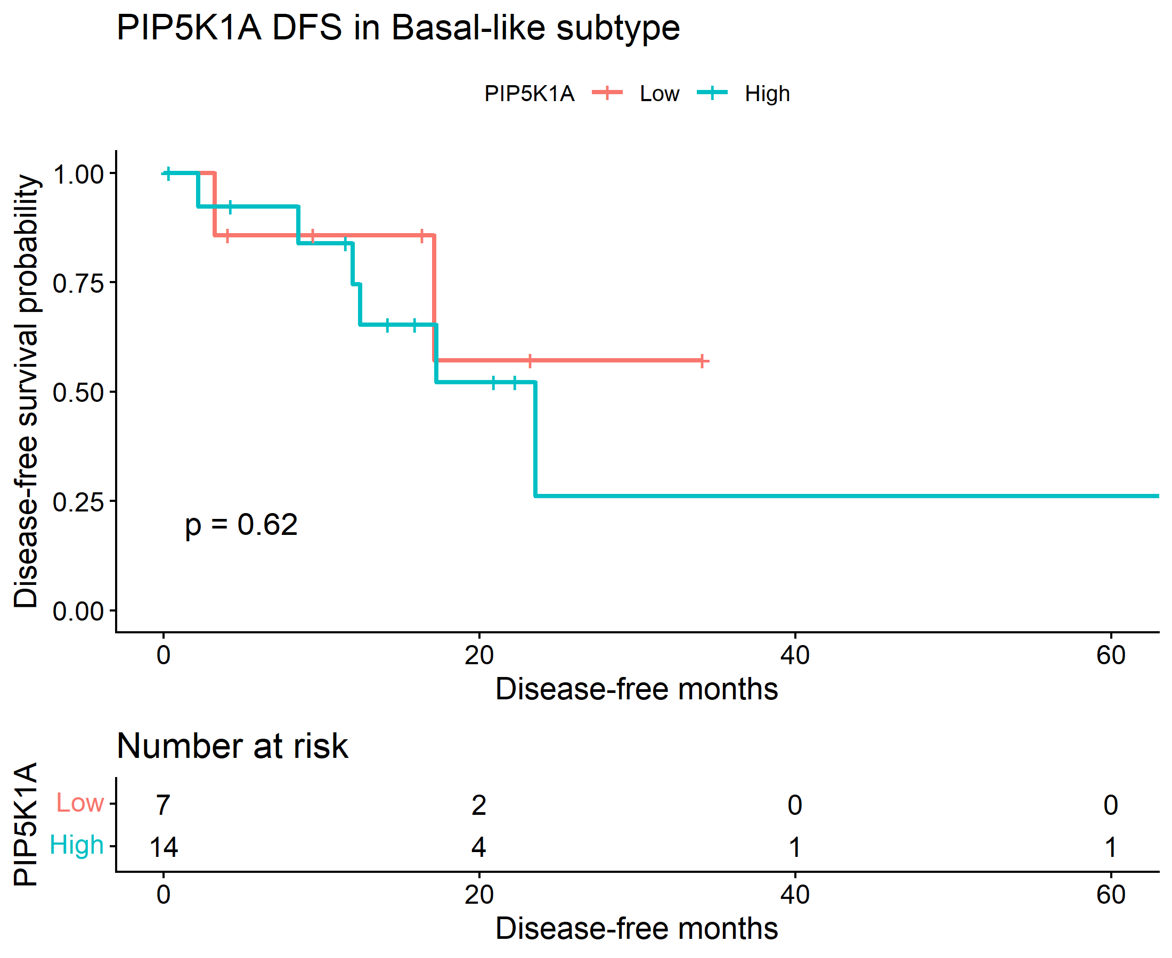
The basal-like KM curve shows separation between low and high PIP5K1A groups, but the log-rank p-value is 0.62, so that difference is not statistically significant. The Cox (results shown below) model also is not significant: HR 1.50 with a wide 95% CI and p = 0.62. So, in basal-like tumors, there is no significant evidence that PIP5K1A expression predicts DFS.
1.2 DFS analysis for PIP5K1A in classical-like subtype in TCGA-PAAD
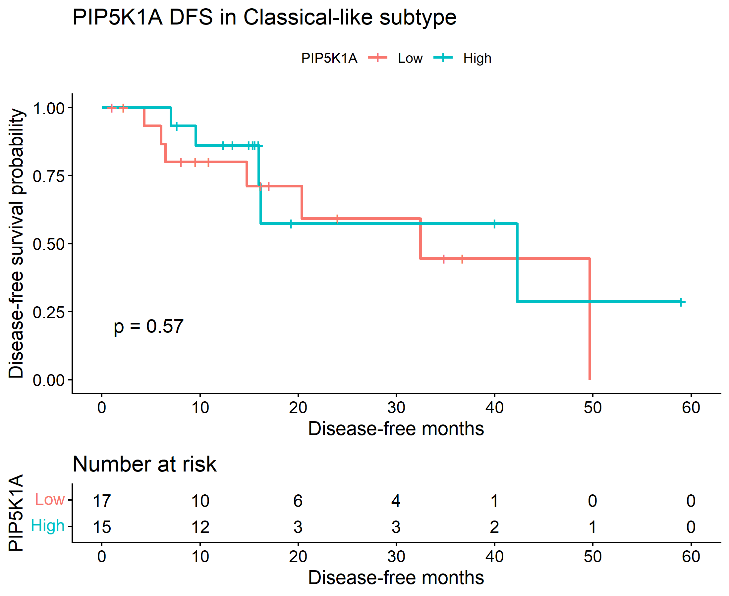
The classical-like KM plot also shows no convincing separation, with log-rank p = 0.57. The Cox model similarly is not significant: HR 0.71 with p = 0.57. This implies that PIP5K1A is not associated with DFS in the classical-like subgroup either.
2. Log-rank test results

Subtype | Chisq | P Value
Basal-like | 0.250458 | 0.616753
Classical-like | 0.325049 | 0.568589

The log-rank table shows non-significant chi-square values for both subtypes: 0.250458 for basal-like and 0.325049 for classical-like. The corresponding p-values, 0.616753 and 0.568589, are both far above 0.05. So, the survival curves are not different enough to reject the null hypothesis.
3. Cox Proportional Hazards Regression Results

Subtype | Hr | Lower_95_Ci | Upper_95_Ci | P Value
Basal-like | 1.501526 | 0.302301 | 7.458057 | 0.619148
Classical-like | 0.713976 | 0.223093 | 2.284976 | 0.570274

The Cox results agree with the KM analysis: basal-like HR 1.50, classical-like HR 0.71, and both p-values are non-significant. The confidence intervals are wide and include 1, which means the effect could easily be null.m This suggests limited precision, likely because the DFS sample sizes are small
4. Interaction and Validation testing results

Term | Coefficient | HR | Lower_95 | Upper_95 | P value | significance
PIP5K1A_z | 0.2612 | 1.2985 | 0.5620 | 3.000 | 0.54095 | NS
Subtype Classical-like | -0.0433 | 0.9576 | 0.3601 | 2.5467 | 0.93080 | NS
PIP5K1A z:subtype Classical-like | -0.1120 | 0.8940 | 0.2951 | 2.7083 | 0.84294 | NS

Cox interaction analysis did not show a significant interaction between PIP5K1A expression and Moffitt subtype, indicating no evidence that the prognostic effect of PIP5K1A on DFS differs between basal-like and classical-like tumors.
Important: All confidence intervals are wide and include 1, so the estimates are imprecise, which usually means limited sample size and/or limited event numbers for the DFS endpoint.

